**Experiment No: 06**

 **Title:** Star and peer to peer topology

(Autonomous College Affiliated to University of Mumbai)

**Batch: B1 Roll No.: 1914078 Experiment No. 06**

**Aim:** To construct Star Topology and Peer to Peer Topology

**Resources Used:** IIT Bombay Vlab

**Theory:**

**Star Topology**

The word physical network topology is used to explain the manner in which a network is physically connected. Devices or nodes in a network get connected to each other via communication links and all these links are related to each other in one way or the other. The geometric representation of such a relationship of links and nodes is known as the topology of that network.  
These topologies can be classifies into two types:-  
1. Peer to peer  
2. Primary - Secondary  
  
Peer to peer is the relationship where the devices share the link equally. The examples are ring and mesh topologies.  
In Primary - Secondary relationship, one device controls and the other devices have to transmit through it. For example star and tree topology.  
Features of Star Topology:-  
1) Every node has its own dedicated connection to the hub.  
2) Hub acts as a repeater for data flow.  
3) Can be used with twisted pair, Optical Fibre or coaxial cable.  
  
Advantages of Star Topology:-  
1) Fast performance with few nodes and low network traffic.  
2) Hub can be upgraded easily.  
3) Easy to troubleshoot.  
4) Easy to setup and modify.  
5) Only that node is affected which has failed, rest of the nodes can work smoothly.  
  
Disadvantages of Star Topology:-  
1) Cost of installation is high.  
2) Expensive to use.  
3) If the hub fails then the whole network is stopped because all the nodes depend on the hub.  
4) Performance is based on the hub that is it depends on its capacity.

**Peer to peer Topology:-**

The word physical network topology is used to explain the manner in which a network is physically connected. Devices or nodes in a network get connected to each other via communication links and all these links are related to each other in one way or the other. The geometric representation of such a relationship of links and nodes is known as the topology of that network.  
These topologies can be classifies into two types:-  
1. Peer to peer  
2. Primary - Secondary  
  
Peer to peer is the relationship where the devices share the link equally. The examples are ring and mesh topologies.  
In Primary - Secondary relationship, one device controls and the other devices have to transmit through it. For example star and tree topology.  
  
Features of Peer to peer:-  
In peer to peer architecture every node is connected to other node directly.  
Every computer node is referred as peer.  
Every peer provides services to other peers as well as uses services of them.  
There is no central server present.  
  
Advantages of Peer to peer:-  
1)  It is easy to install and so is the configuration of computers on this network,  
2)  All the resources and contents are shared by all the peers  
3)  P2P is more reliable as central dependency is eliminated. Failure of one peer doesn’t affect the functioning of other peers.  
4) There is no need for full-time System Administrator. Every user is the administrator of his machine. User can control their shared resources.  
Disadvantages of Peer to peer:-  
1) In this network, the whole system is decentralised thus it is difficult to administer. That is one person cannot determine the whole accessibility setting of whole network.  
2) Data recovery or backup is very difficult. Each computer should have its own back-up system.

**Procedure:-**

1) The aim is to Create the topology.  
2) To perform the experiment follow the below steps  
3)A blank square area would be given which defines the working area  
4)A series of components would be given  
5)In order to build a topology first select on the component and then immediately click on the working area to place it  
6)To draw a line between two components first select the line click on the port of first component and then immediately click on the port of second component  
7)Once the topology is build then click on the Submit button to test whether the give topology is built correctly or not.

**Vlab Outcomes:**

**Star Topology**

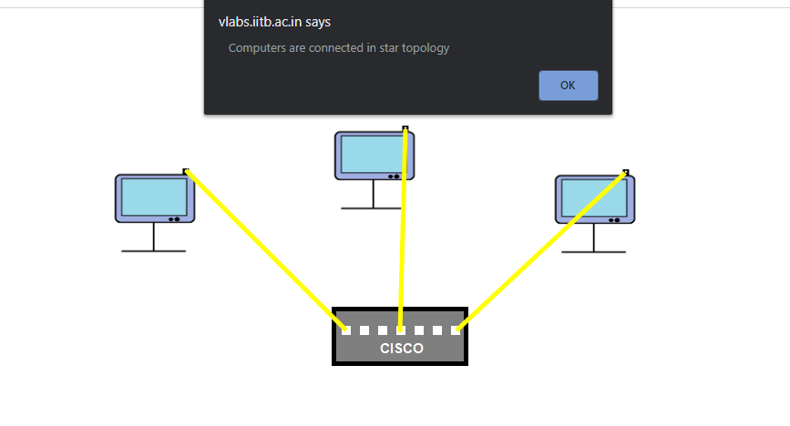

All the connections are dependent on the hub that is used to transfer data from one device to another. If the hub fails or if it’s performance is low then there can be a malfunction in transfer of information and no longer the devices can communicate among themselves. Here 3 computers are connected using optical fiber cabling is typically used to connect devices to the hub, though coaxial cable or Unshielded Twisted Pair (UTP) Ethernet may also be employed.

**Peer to peer topology:-**

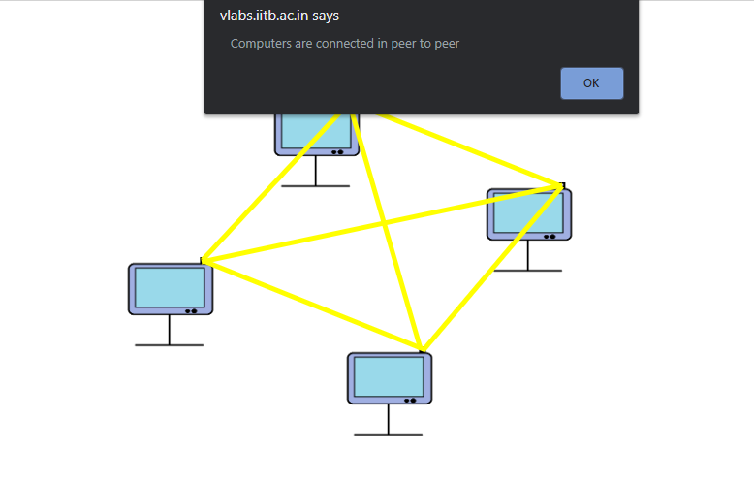

The connections made in peer to peer topology do not involve any interim device making it independent of failure of the data transfer device. All the devices can communicate among themselves and even if one device fails due to a malfunction, the other devices can still transfer data and the connection is active and data transfer is possible because each device has **dedicated connection** to other device.

**Outcomes:** CO1: Understand the data communication systems, network topologies and network devices.

**Conclusion:** We constructed both star and peer to peer topologyand understood how each topology can be useful based on it’s requirement.



**Grade: AA / AB / BB / BC / CC / CD /DD**

**Signature of faculty in**

**-**

**charge with date**

**References:**

**Books/ Journals/ Websites:**

* + B. A. Forouzan and Firouz Mosharraf, ”Computer Networks ”, A Top-Down Approach, Special Indian Edition 2012, Tata McGraw Hill.
  + Behrouz A Forouzan, Data Communication and Networking, Tata Mc Graw Hill, India, 4th Edition
  + http://vlabs.iitb.ac.in/vlabs-dev/labs_local/computer-networks/labs/explist.php